|  |
| --- |
| Developer’s Hub Corporation |
| Cybersecurity Internship Report |
| Made by: Tayyab Khurram  Week: 2  Student-ID: DHC-3381 |

# Week 2: Implementing Security Measures

## 1. Sanitize and Validate Inputs:

* Input validation: Only integers allowed.
* Sanitization: htmlspecialchars() used when displaying output (XSS protection).
* Prepared statements: Prevent SQL injection.

**BEFORE**

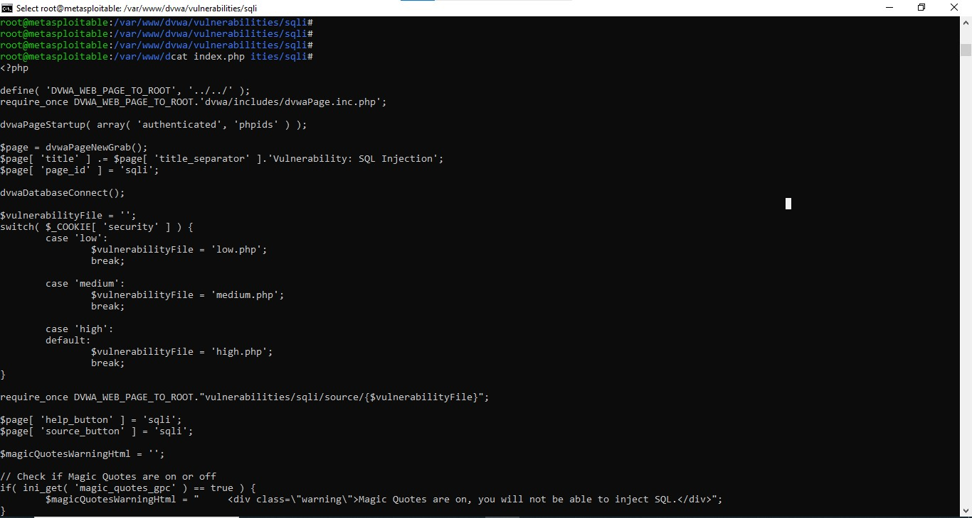

**AFTER**

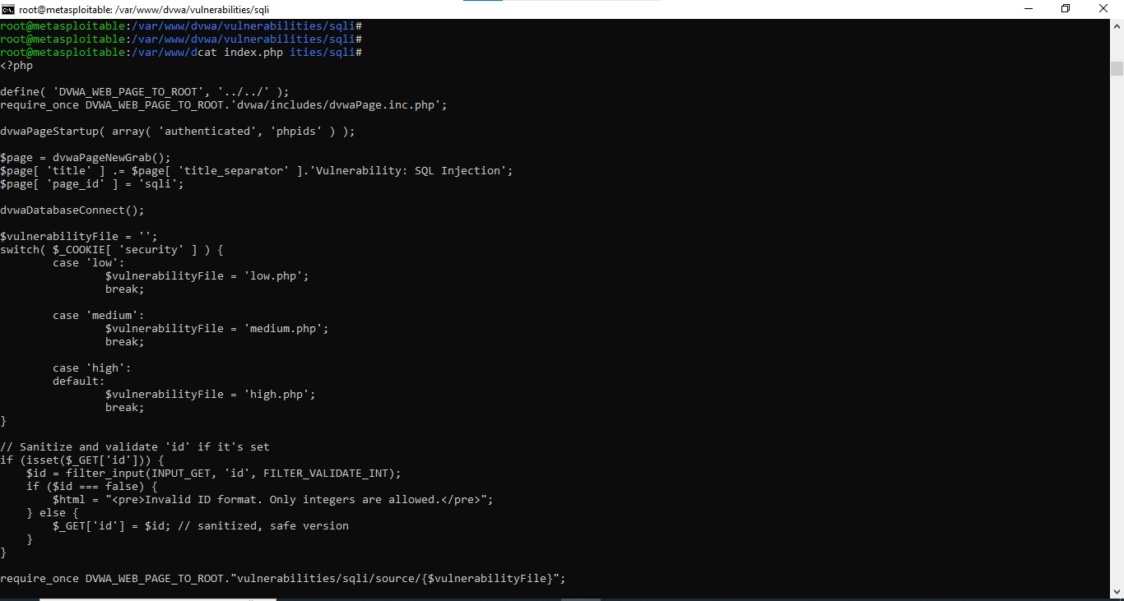

## 2. Password Hashing:

* Use mysqli or PDO
* Use password_hash() and password_verify()
* Use prepared statements
* Sanitize and validate inputs

**BEFORE**

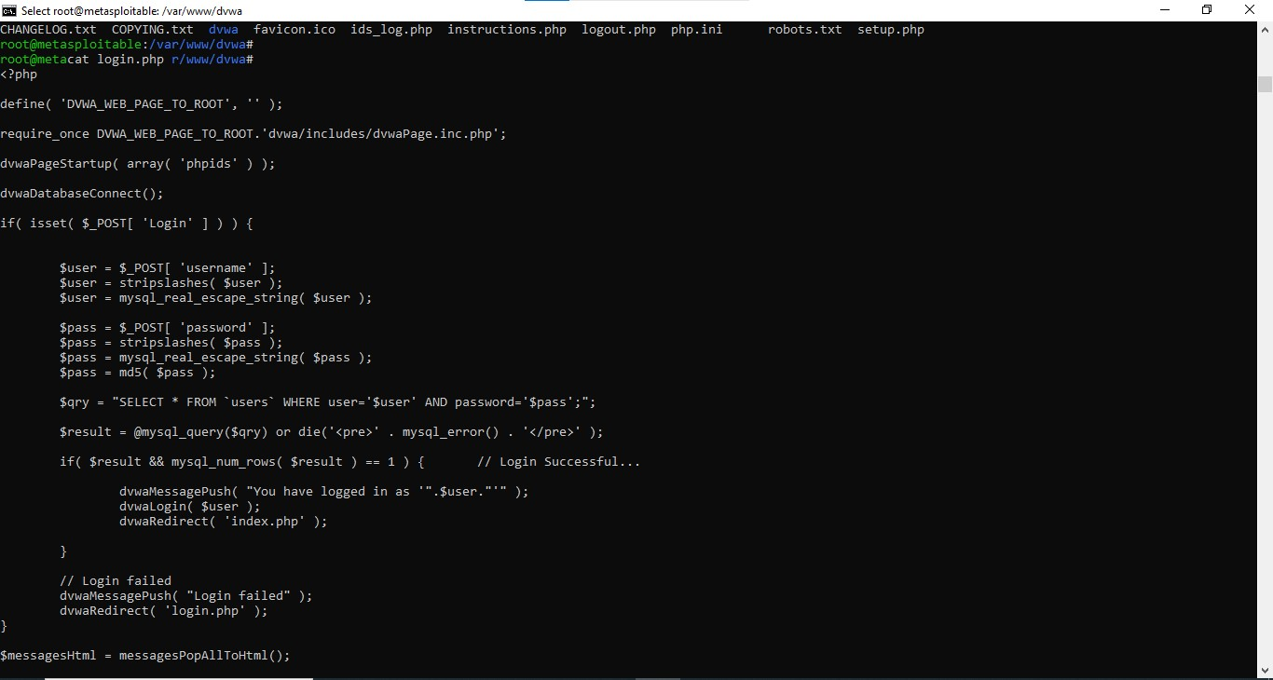

**AFTER**

